**Group Project Documentation**

***Apartment Management System - Process of Parking Management***

**Prepared by Group 2**

Trần Chí Hiếu

Trương Minh Tuấn

Nguyễn Đức Vinh

**Ho Chi Minh City, 2022**

**Table of Contents**

Project Introduction 1

Product Perspective 1

User Classes and Characteristics 1

User 1

Manager 1

System Architecture 3

Implementation 4

Deployment Considerations 4

Screenshots and explanations 5

References **42**

**Extras** **42**

# **Project Introduction**

## **Product Perspective**

Apartment buildings are one of the real estate models that many investors are interested in and exploiting. Apartment buildings are buildings that own many apartments, offices for rent and public works used by a large volume of residents and customers. And with that comes the problem of managing parking slots for residents as well as guests and workers there. Currently the system is hand-documented and everything is written in paper form, not convenient for reporting as well as statistics for both the user as well as management staff. For that we offer our solution to this is the parking management web app where users can register their parking info as well as booking for it, management staff can manage parking slots as well as checking on information of the parking lot itself.

## **User Classes and Characteristics**

## **User**

* A user is someone who uses the Parking Management system to book a parking space in the apartment’s parking lot. A User can: view own profile, view registered vehicles, view parking slots, book a parking slot.
* Use case:

1. Booking a parking slot
2. Viewing own profile
3. View registered vehicles
4. View parking slots

## **Manager**

A Manager is someone who manages the Parking Management system operations. They are responsible for: managing users’ accounts, managing parking slots, managing parking pricing.

Use case:

1. Manage parking slots
2. Manage parking pricing
3. Manage users’ accounts
   * 1. **Administrator**

An Administrator is responsible for managing Managers. In addition to manager’s capability, an administrator can also manage managers’ accounts.

Use case:

1. Manage parking slots
2. Manage parking pricing
3. Manage users’ accounts
4. Manage managers’ accounts.

**Database Design**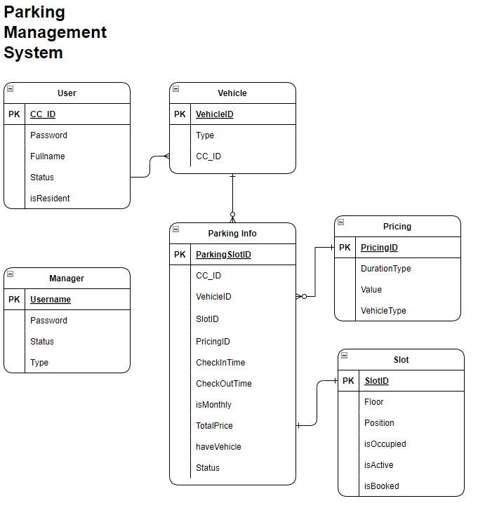 Entity Relationship Diagram

# **System Architecture**

**3.1. Client-side Requirements**

A personal computer with the following minimum specifications:

- An x86 or x64 processor

- 512MB of RAM

- 5GB of free storage space

- Softwares required:

- Operating system: Microsoft Windows 7 or Higher

- Microsoft SQL Server

- .NET Framework 5.0

**3.3 System Architecture**

* The system is implemented using .NET RazorPage technology, and using 3-tier model.
* Database is implemented using Microsoft SQL Server.

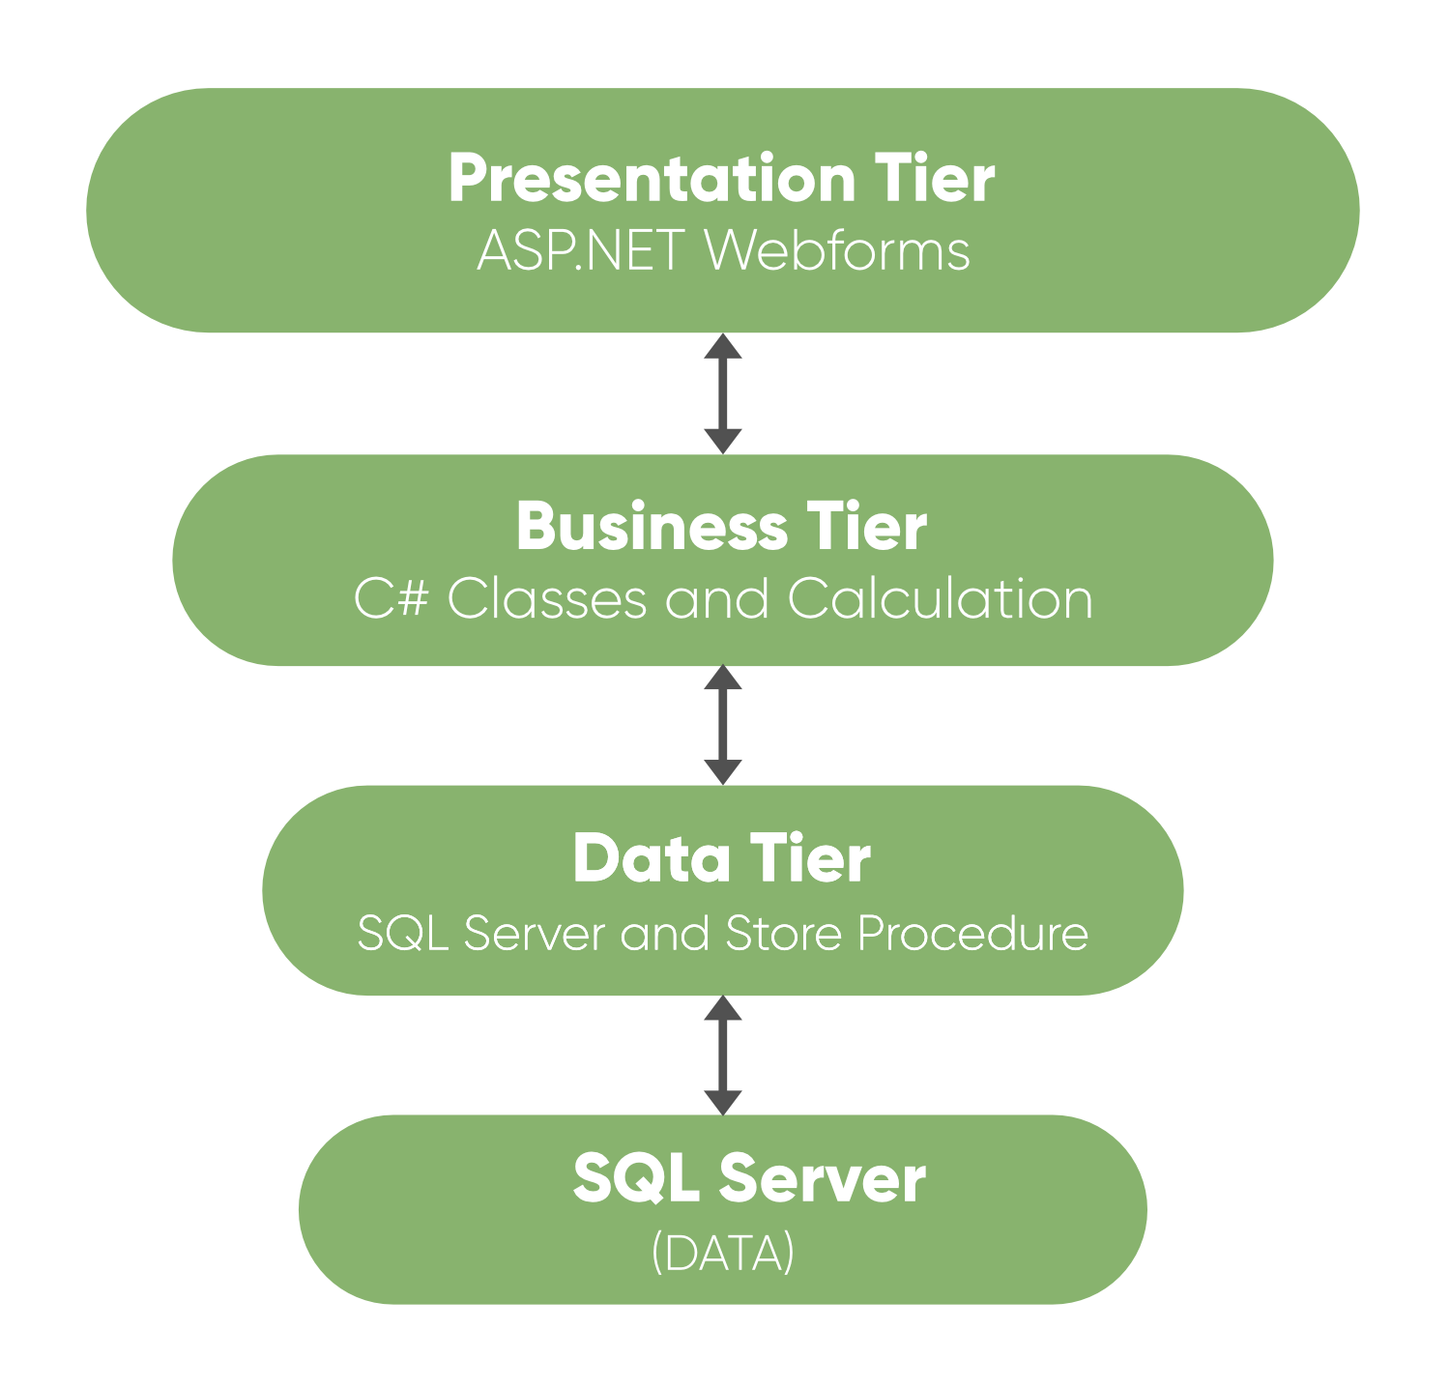

# **Implementation**

## **Deployment Considerations**

* To ensure successful deployment, a stable internet connection is required for both client and server.

## **Screenshots and explanations**

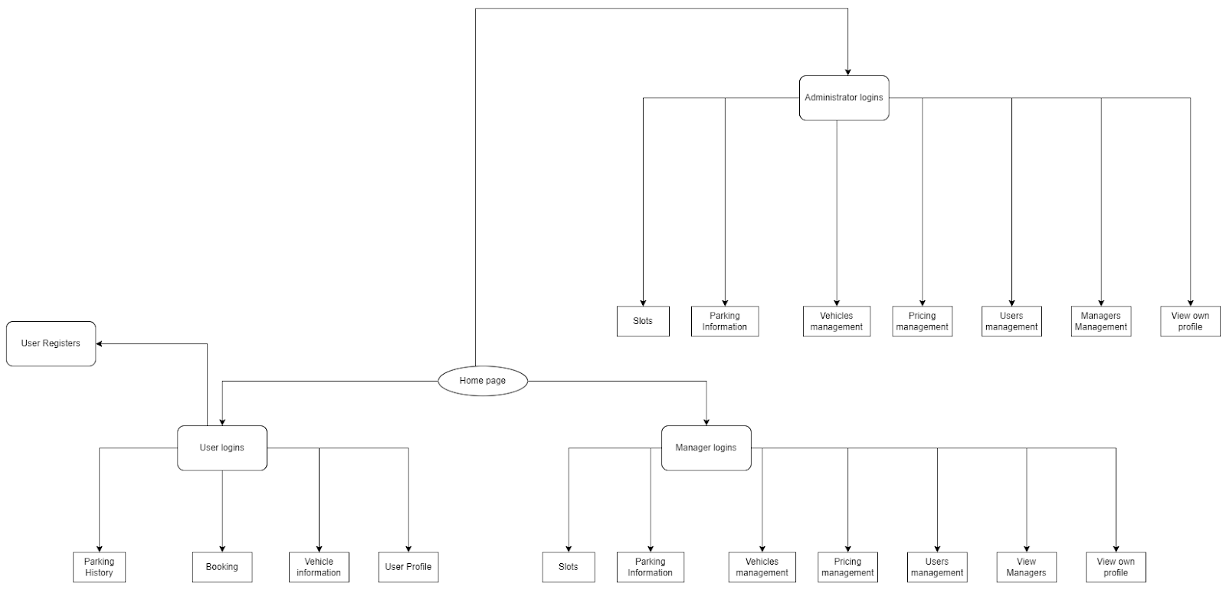

Screen flow of the application.

**Screenshots:**

1. **Login**

Users of the application login using their CCID (for User) or using their Username (for Manager/ Administrator). If login is successful, the user is redirected to the home screen. Otherwise, an error message is shown.

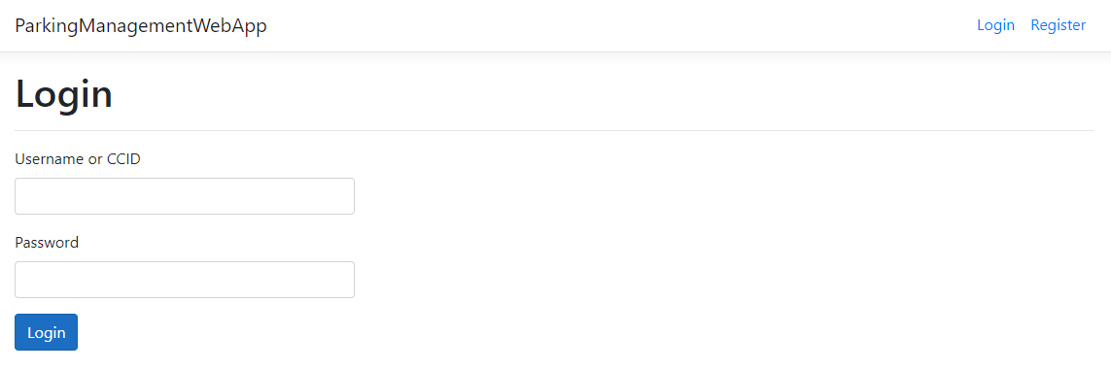

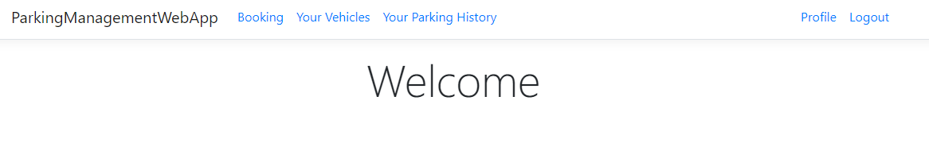

Main screen of the application (User)

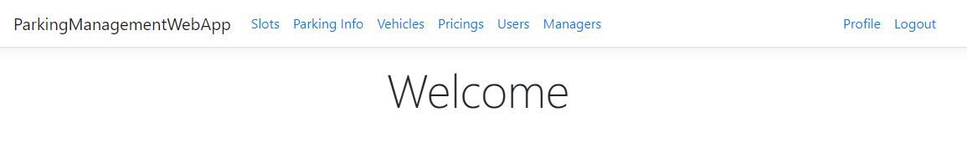

Main screen of the application (Manager/ Administrator)

1. **Manage own vehicle**

A user is able to manage their vehicles after login in. They can register new vehicle to the system, view a list of their registered vehicles, and view details of the vehicle.

* After login in, user is able to manage their vehicle via the “Your Vehicles” button.

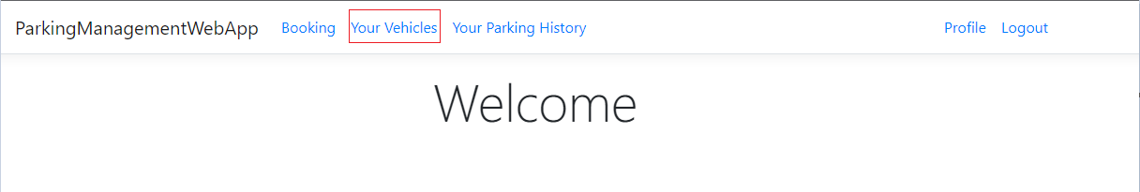

* Users can manage the vehicles that they registered to the Parking Management system.
  + User can view registered vehicles

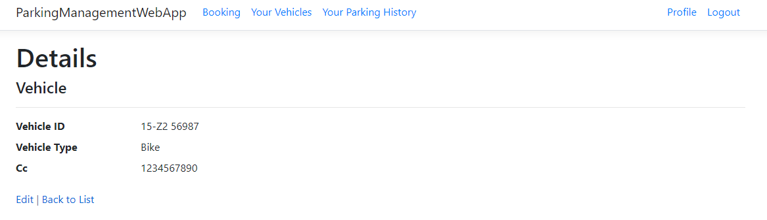

* User can register new vehicle

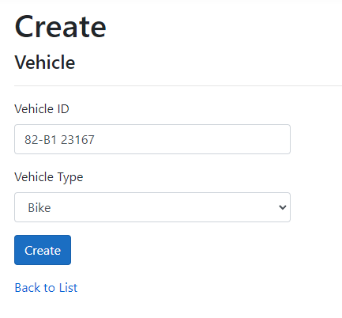

* (Note: Vehicle license plate number must follow Vietnamese format.)

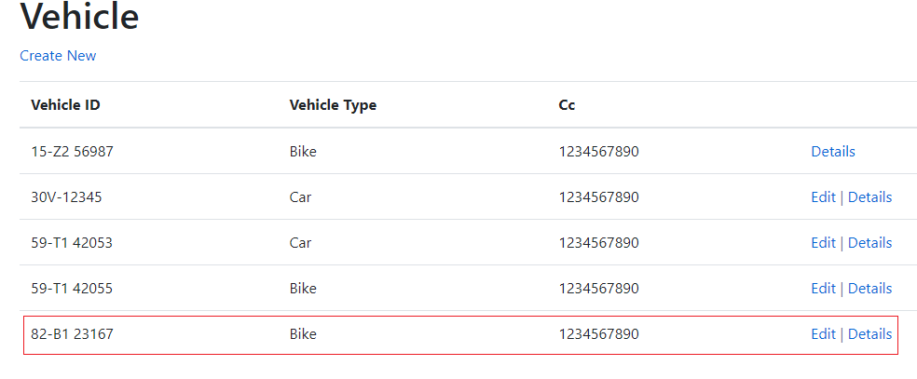

1. **Book a parking slot**
   1. General

A User is able to book a parking slot in the system. There are 4 booking types:

* Book immediately.
* Book immediately, with monthly payments.
* Book in advance.
* Book in advance, with monthly payments.

After selecting the vehicle and booking type, the user then selects any available slot. The system will show confirmation and pricing before the user accepts booking.

1. **Book immediately**

(User will register a slot for immediate parking, but currently not knowing the time the user will take the vehicle out, this booking will have it status as active when created, total money in this case will be calculated using the time between the user finish parking and the time the booking is created)

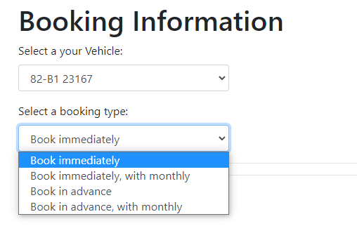

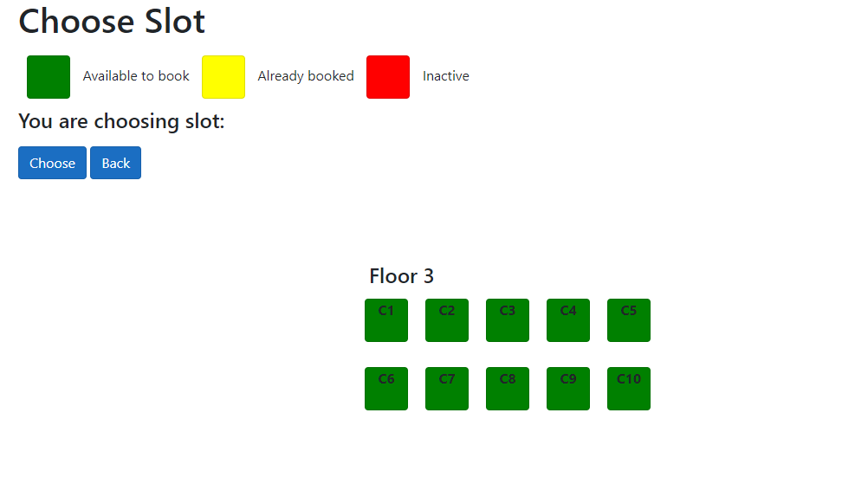

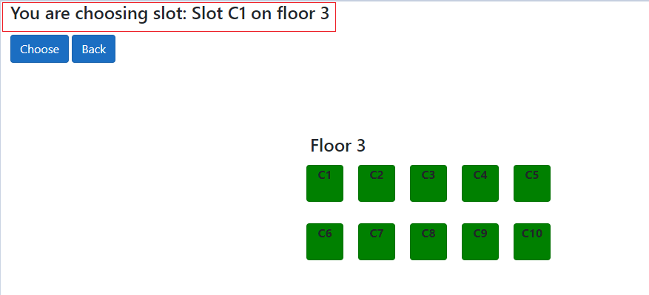

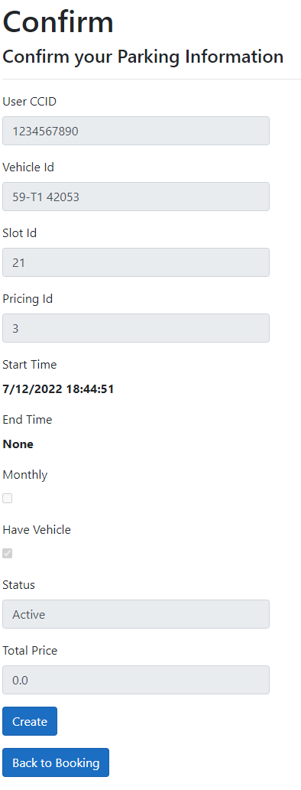

* Pricing will be before the vehicle leaves the parking lot, based on the hours the vehicle had stayed in the parking lot.
* The money is calculated by each 8h time span multiply with temporary pricing based on the type of vehicle
  1. **Book Immediately, with monthly**

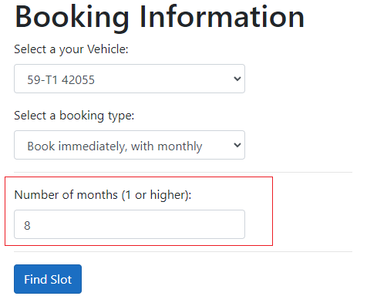

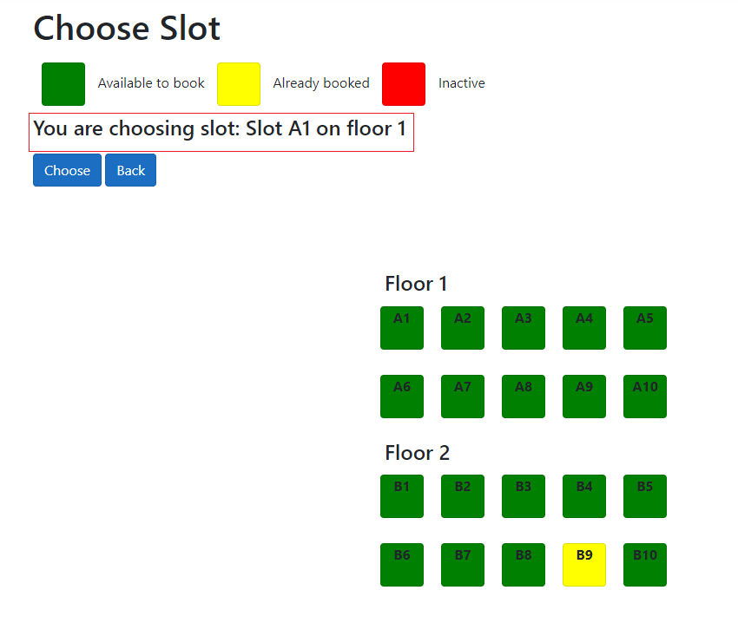

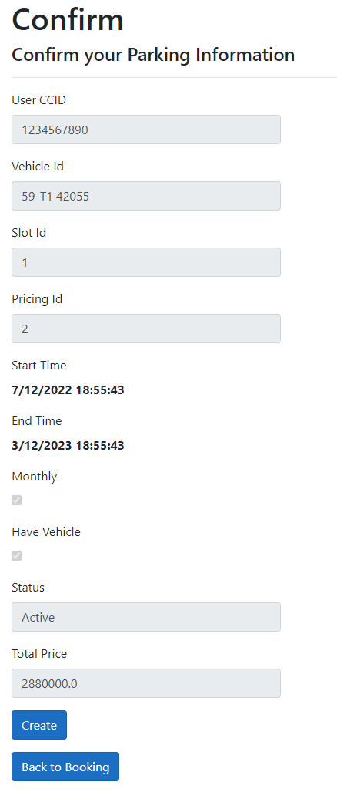

* 1. **Book in advance**

User enters start date and end date

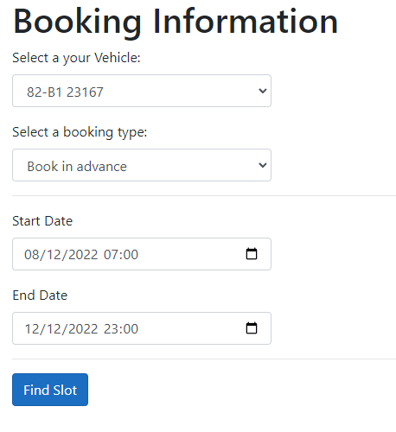

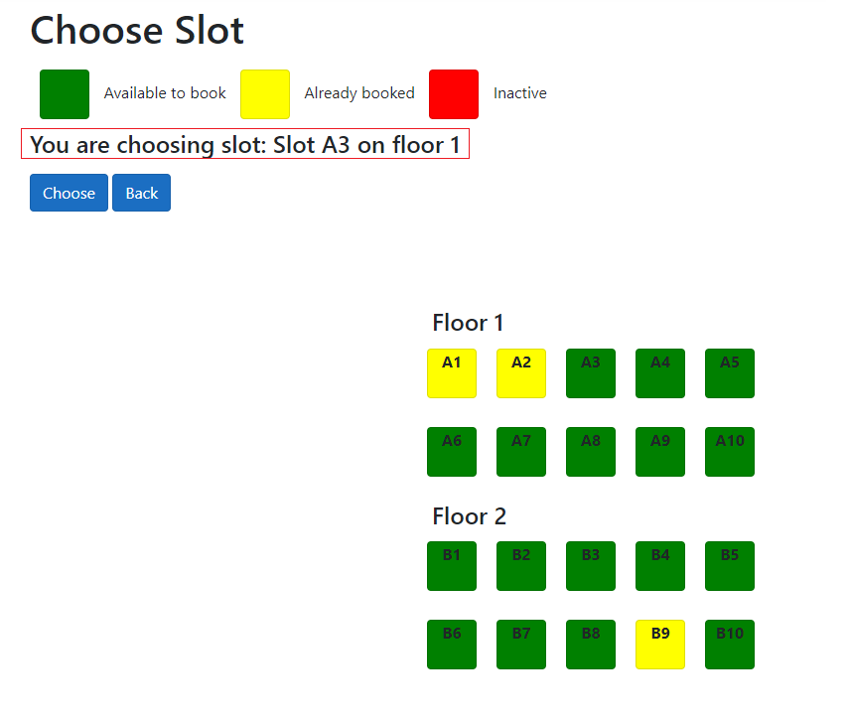

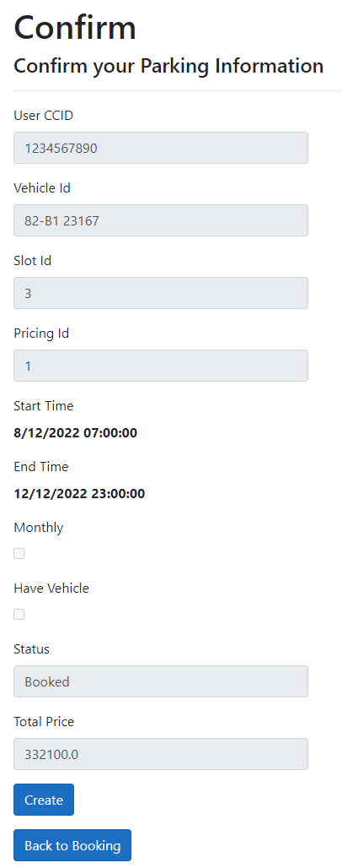

* 1. **Book in advance, with monthly**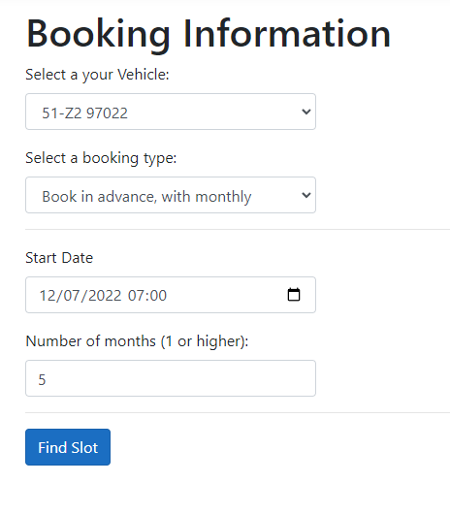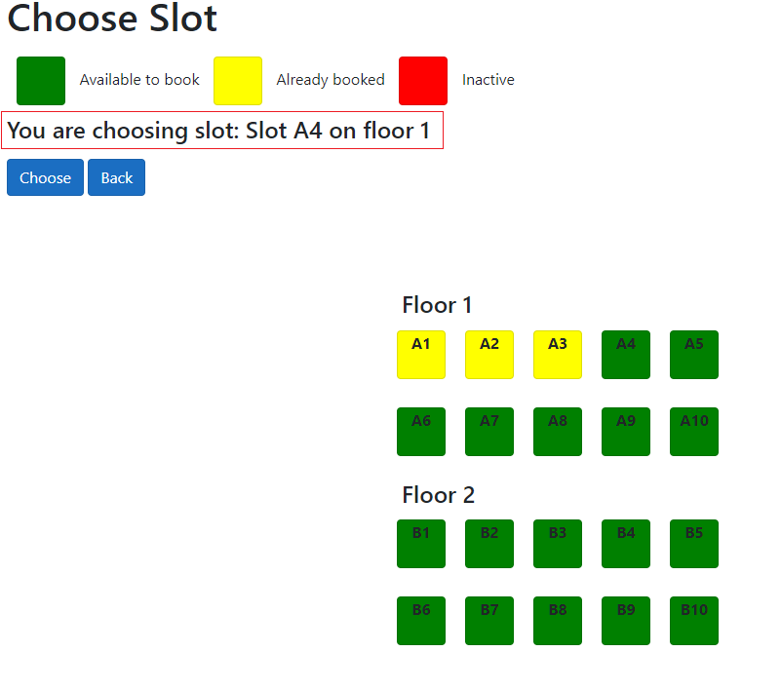

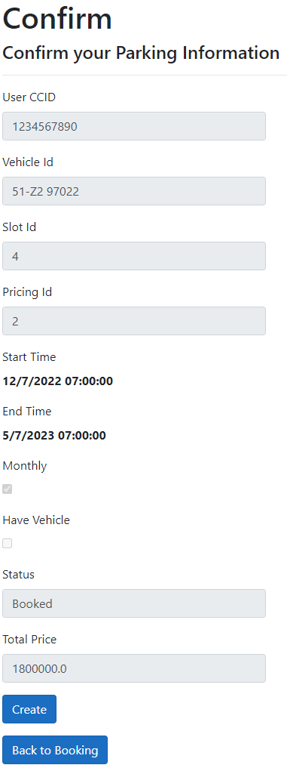

1. **Parking history**

Users can view a list of their parking history. This list includes currently parked vehicles, as well as past parking histories. Additionally, users can change their vehicle parking slot and extend parking duration (booking type 2,3,4 only).

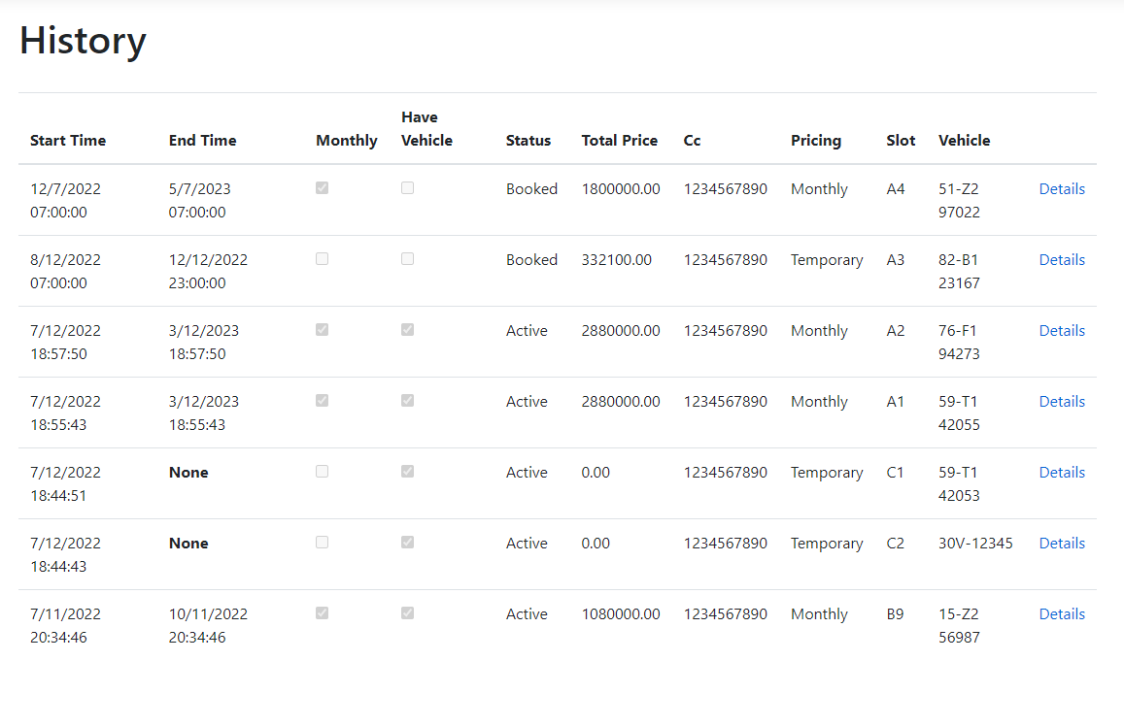

1. **Extension on parking duration**

* For parking with monthly and in advance (type 2,3,4), user can extend their parking duration



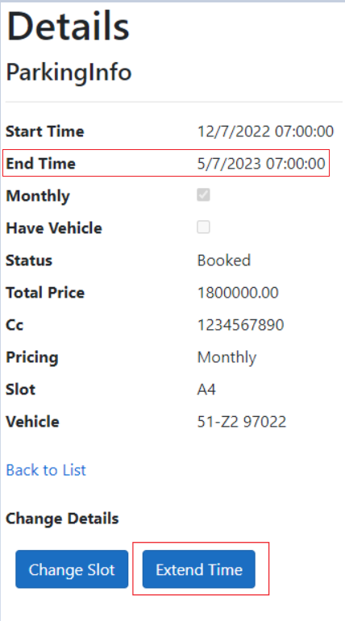

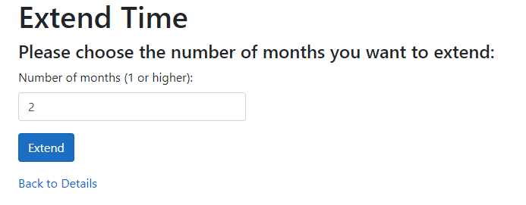

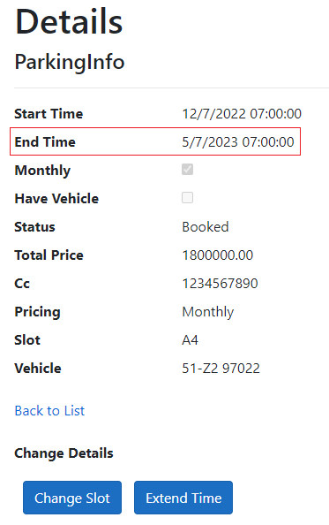

1. **Change parking slot**

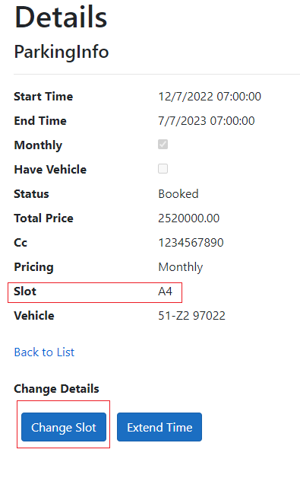

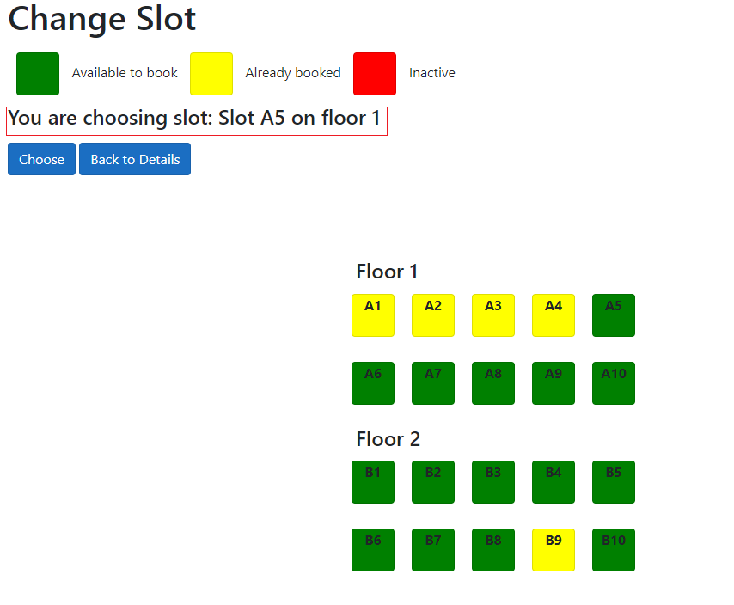

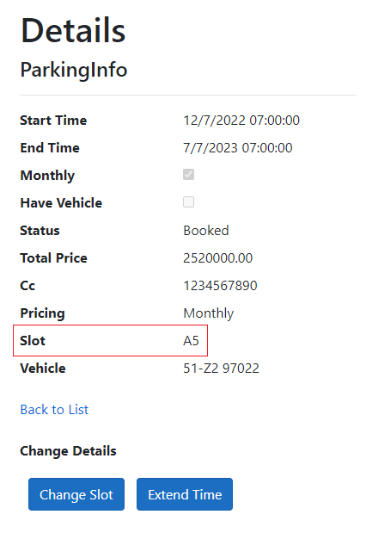

1. **View own profile**

* By pressing “Profile”, the user is able to manage their own profile.

1. **User**

* A user is able to view their own profile. They are allowed to change:
  + Full name
  + Password
  + Apartment residency status

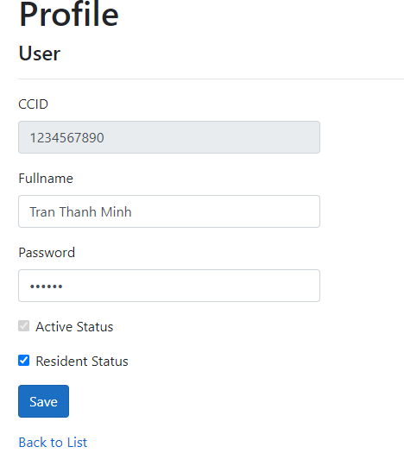

1. **Manager/ Administrator**

* A manager/ administrator is able to view their own profile. They are allowed to change their password.

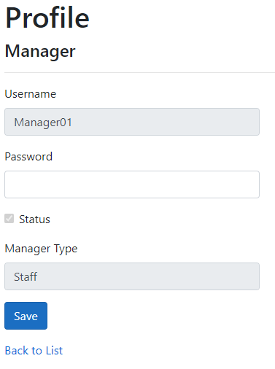

1. **Manager manages slots**

* A manager can manage parking slots by pressing on the “Slots” button.
* The slots page view shows all slots in the parking lot and their information - Their floor, position, and status
* Manager can disable a particular parking slot.

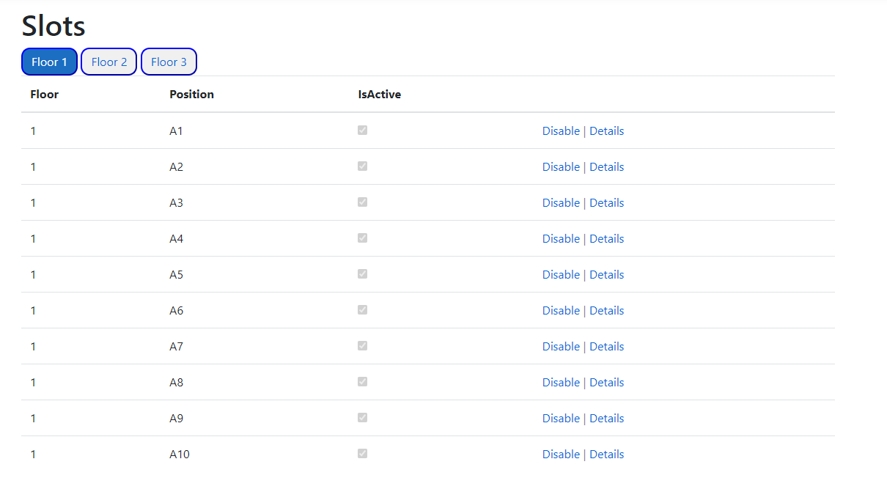

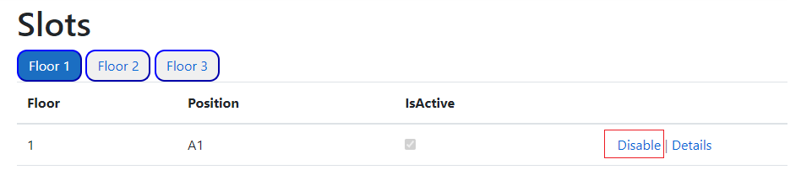

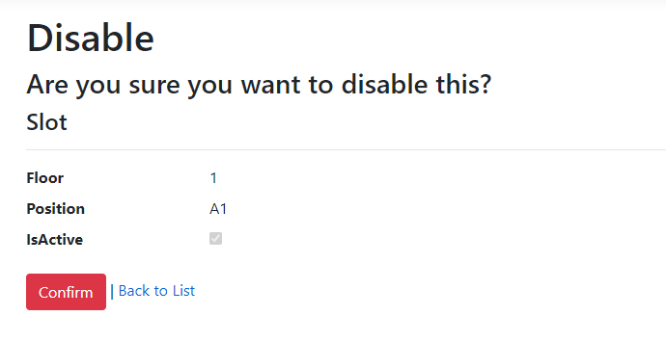

* If the slot is already occupied, disabling the slot is not possible. 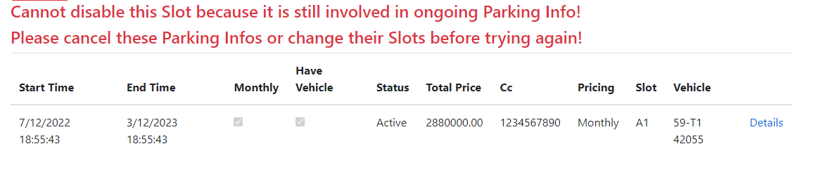
* Manager can only disable empty slots.

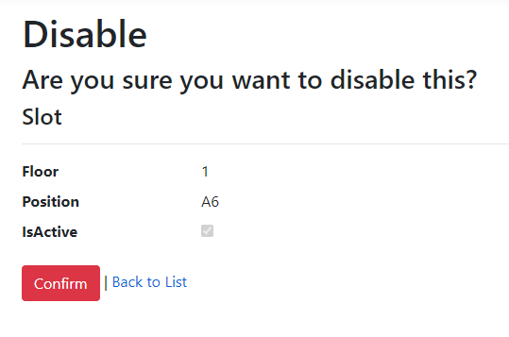



1. **Manager manages parking**

* A Manager is able to view all parking information in the system by pressing the “Parking Info” button.
* Initial parking infos view will show all currently booked slots, and their information and status.
* Filtering by slot status function is also available.

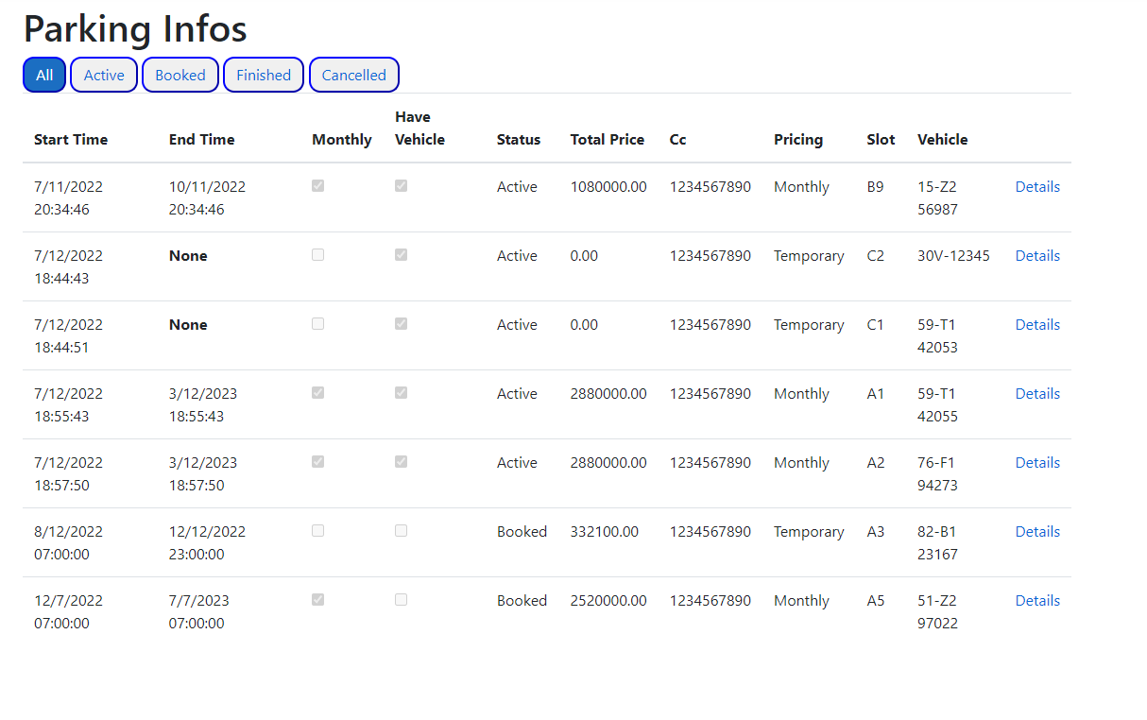

1. **Parking details**

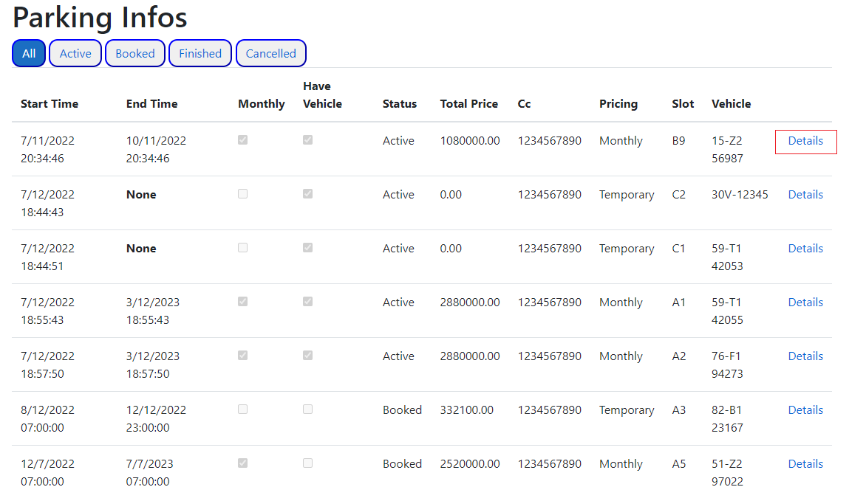

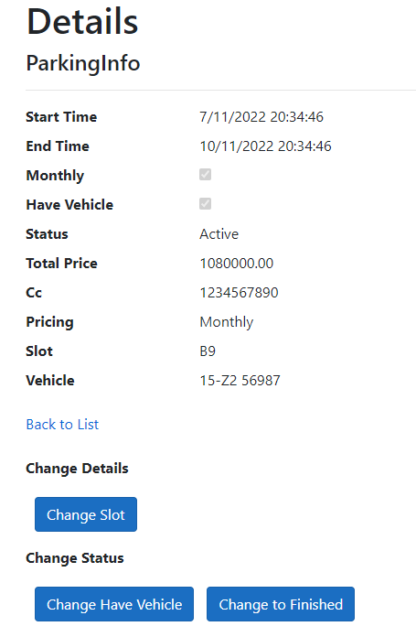

1. **Changing slot**

Manager can change a vehicle’s parking slot to another currently available slot.

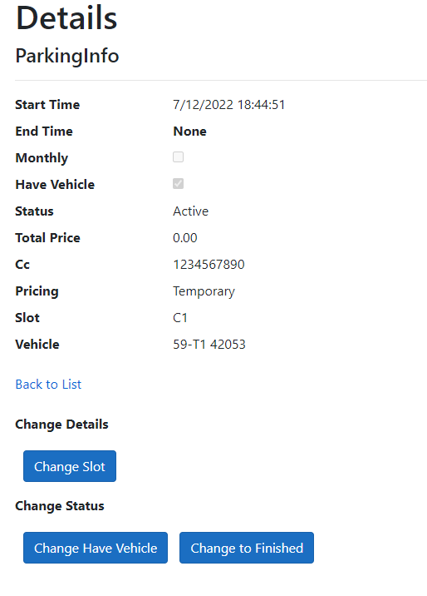

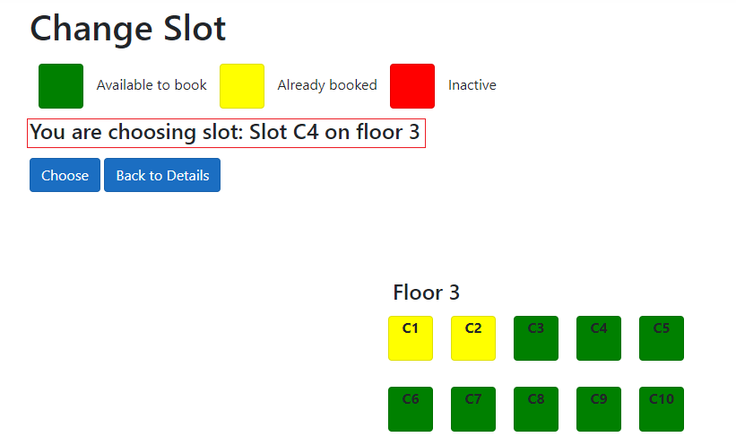

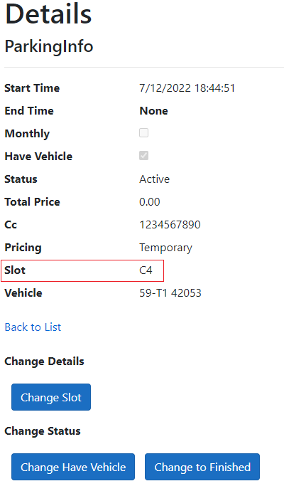

1. **Changing status**

In details screen, manager can change vehicle status or end the booking

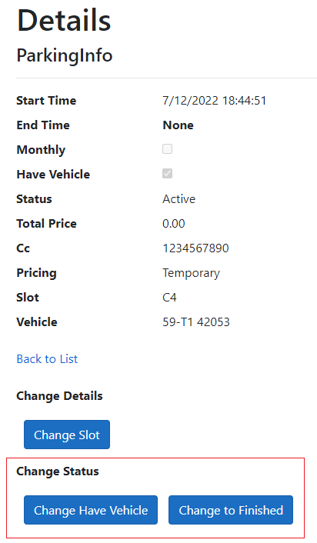

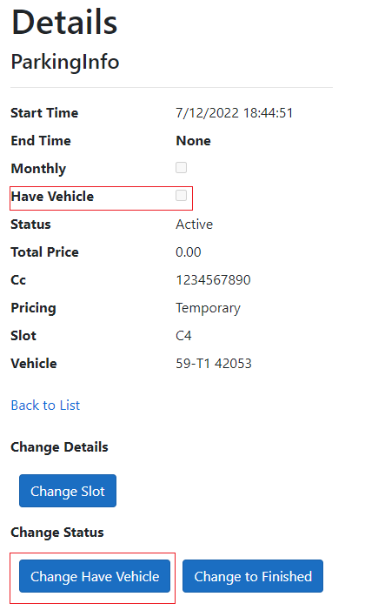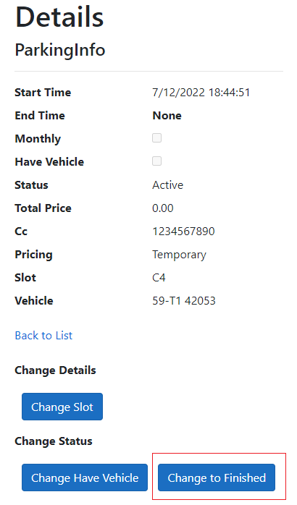

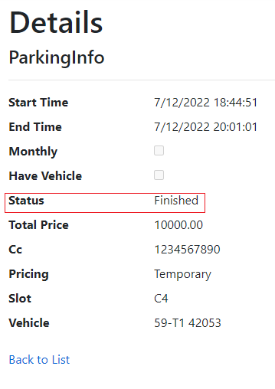

1. **Manager views Vehicles**

Manager can view vehicles registered to the system by pressing “Vehicles” button

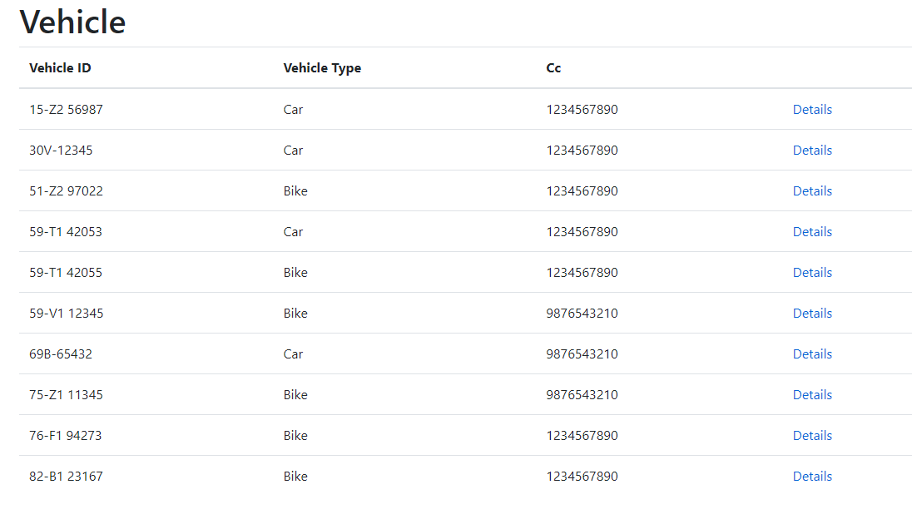

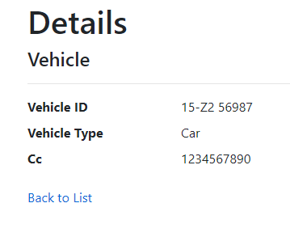

1. **Manager manages Users**

* Manager can view registered users by pressing the “Users” button. User’s information include CCID, Full name, Active status and Residency status.
* Manager can disable or enable a user’s account.

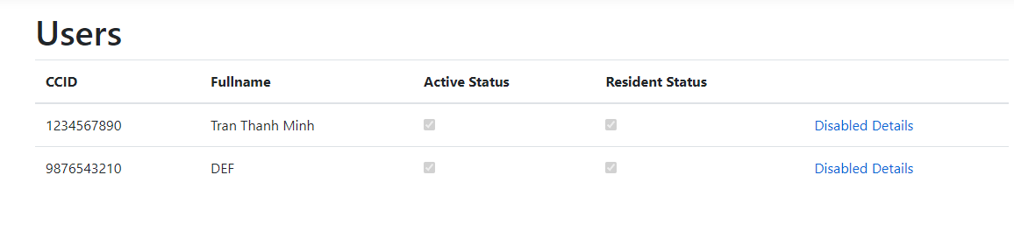

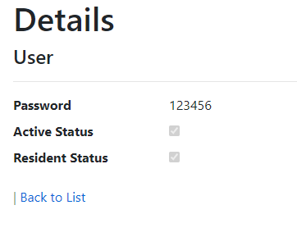

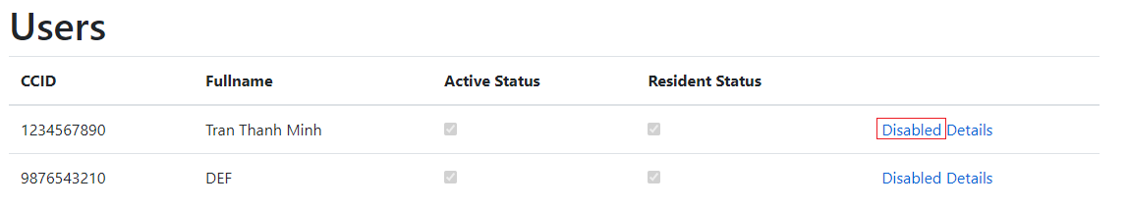

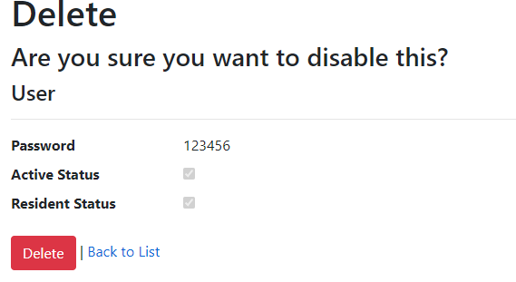

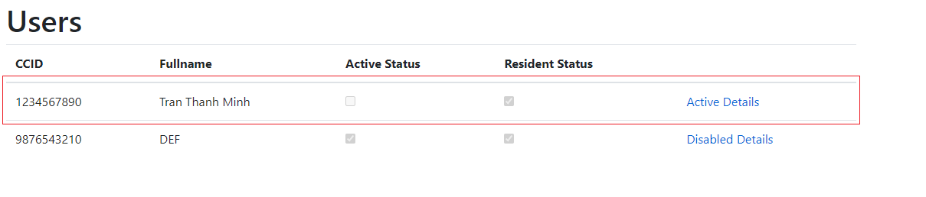

1. **Manager manages pricings**

* Manager can manage the system's parking pricings by pressing the “Pricings” button.
* Currently, the system has 4 types of pricing: Temporary and Monthly, for either Car or Bike.
* Manager is allowed to edit pricing values only.

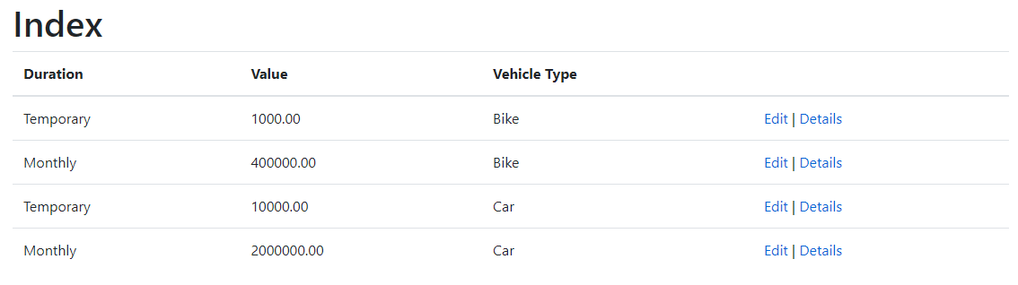

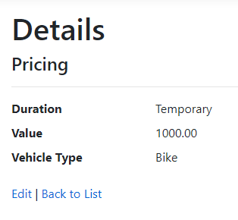

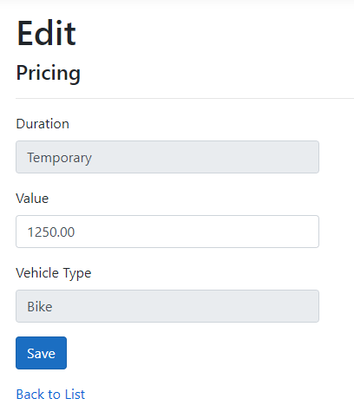

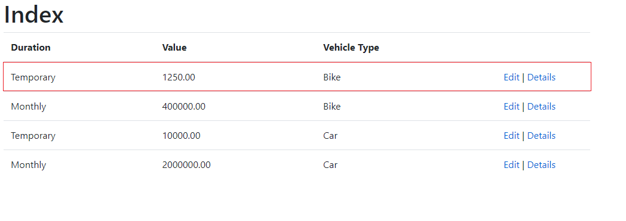

1. **Administrator manages manager**

* An Administrator is able to manage managers in the system. The administrator can
  + Create a new manager account.
  + View a manager’s details, and disable/ enable a manager’s account.

1. **Create a new manager account**

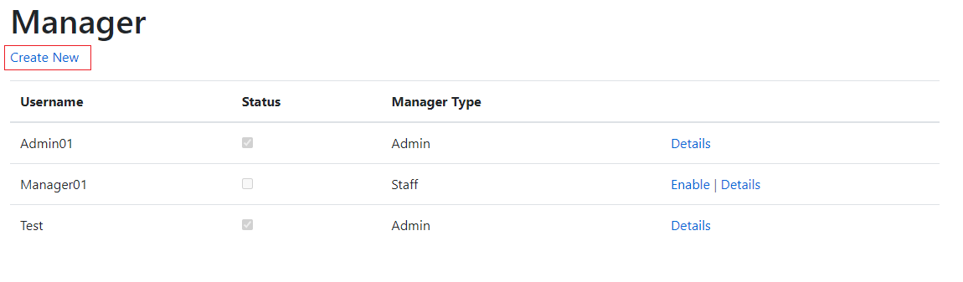

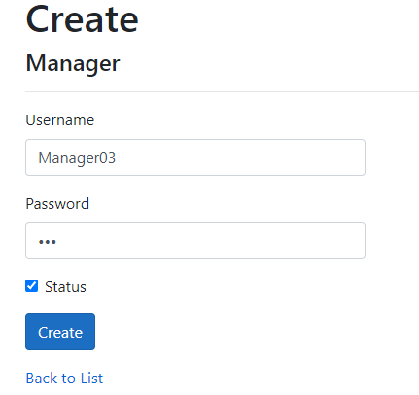

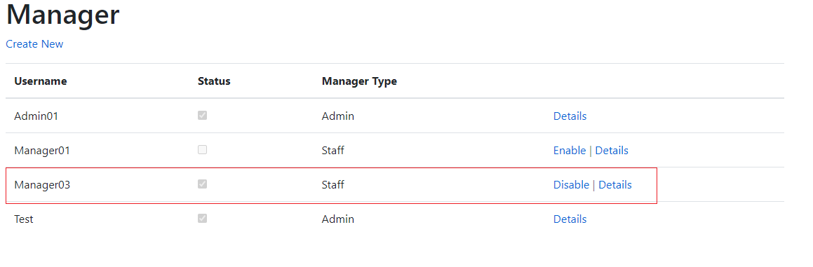

1. **View details and disable/enable manager account**

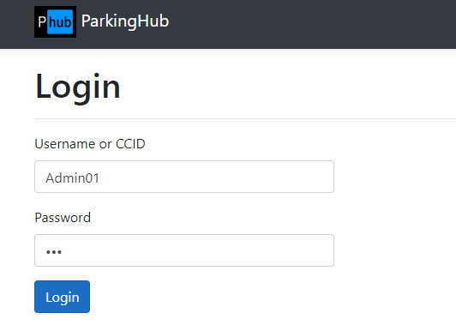

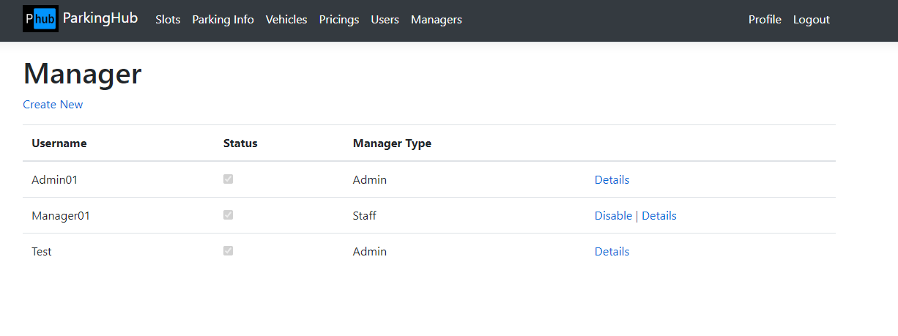

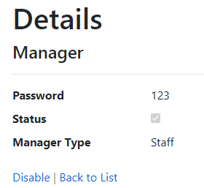

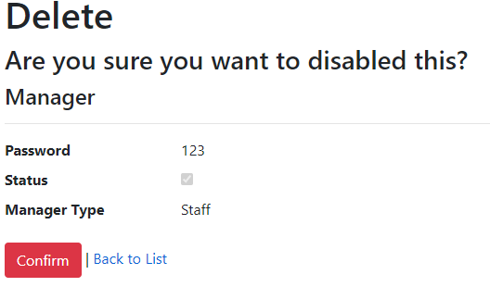

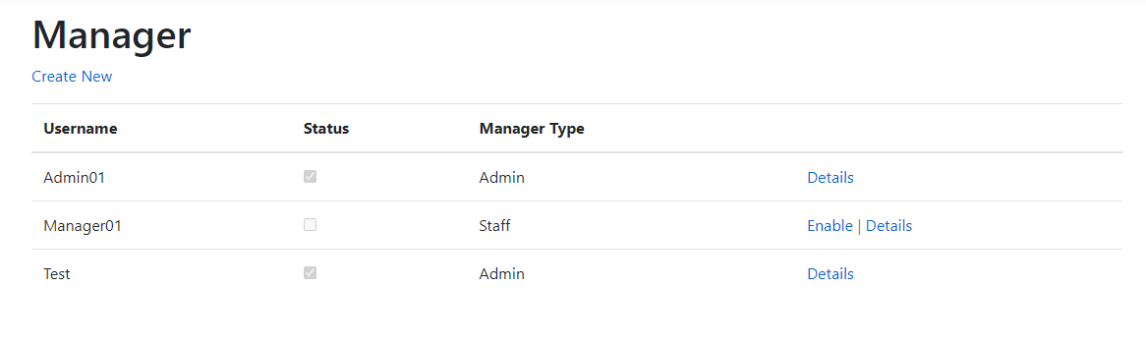

# **References**

# Extras

1. Class Diagram
   1. [Link](https://drive.google.com/file/d/1Tuyvc7q_4B6TB38WFQdoHkPEgaLuaX2S/view?usp=sharing)
2. Business Rules

| **Rule ID** | **Rule Definition** | **Type of Rule** | **Static or Dynamic** | **Source** |
| --- | --- | --- | --- | --- |
| BR-1 | User login via CCID and password | Constraint | Static | Administrator |
| BR-2 | Managers login via Username and Password | Constraint | Static | Administrator |
| BR-3 | CCID must be between 9 - 12 numbers | Constraint | Static | Administrator |
| BR-4 | Pricing currency is Vietnamese Dong (VND) | Inference | Static | Administrator |
| BR-5 | CCID must be unique | Fact | Static | Administrator |
| BR-6 | Vehicle registration plate number must be unique | Fact | Static | Administrator |
| BR-7 | Admin can manage managers’ information, as well as delete manager | Fact | Dynamic | Administrator |
| BR-8 | Manager cannot view or update other manager’s information | Fact | Dynamic | Administrator |
| BR-9 | Administrator and Manager can manage users and change their state in the system (enabled/ disabled) | Fact | Dynamic | Administrator |
| BR-10 | Administrator and Manager can manage parking slots | Fact | Dynamic | Administrator |
| BR-11 | Vehicle number plate will follow vietnamese format | Fact | Static | Vietnamese policy |
| BR-12 | The parking compartment consist of 3 floor each floor has 10 slot and with floor 1 and 2 for bike and 3 for car | Fact | Static | Apartment Policy |

1. Dialog Map/ Screen flow

